**Set up a go development environment**

**Prerequisites**

1. **We want the latest stable Go distribution https://golang.org/dl/**
2. **We will install on Ubuntu as this is the most stable, suggest set up a VM for win/mac**
3. **Create a GitHub account if you do not have one already https://github.com**
4. **Download and Install Intellij Community Edition** [**https://www.jetbrains.com/idea/download/**](https://www.jetbrains.com/idea/download/)

**Objectives**

1. **Install Go distribution**
2. **Configure Go distribution environment** “GOROOT”
3. **Create a workspace based on GitHub user handle**
4. **Configure Go workspace environment** “GOPATH”
5. **Install Intellij ‘Go’ plugin for code completion**

**Install Go distribution**

Go suggests this

**sudo tar -C /usr/local -xzf go1.5.2.linux-amd64.tar.gz**

but it is easy to forget and if you work with a team it is better to install in an explicit location like $HOME:$GOROOT

**sudo tar -C /home/<user dir>gotools -xzf go1.5.2.linux-amd64.tar.gz**

for this situation $HOME is your user directory

GOROOT= /gotools

and we need to put $GOROOT/bin on the system path in .bashrc or /etc/environment

**Configure Go distribution environment** “GOROOT”

$GOROOT so it resolves to /home/<user dir>/gotools

we need to put the $GOROOT/bin on the system path in .bashrc

**export GOROOT=/home/<user dir>/gotools**

**export PATH=$PATH:$GOROOT/bin**

Ubuntu suggests to use the /etc/environment

this will look like

**GOROOT=/home/<user dir>/gotools**

**PATH="/usr/local/sbin:/usr/local/bin:/usr/sbin:/usr/bin:/sbin:/bin:/usr/games:/usr/local/games:/home/<user dir>/gotools/bin"**

then we type

**go -version**

**Create a workspace based on GitHub user handle https://github.com**

in your home user directory create a directory ‘golang’ then create sub directories as shown below ‘bin’, ‘pkg’, ’src’

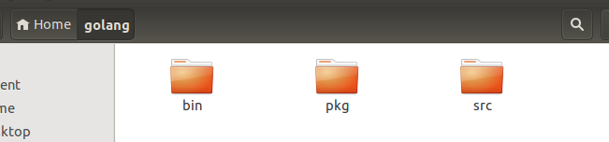

now locate the package path from your github handle, for example for the github url below for the user nsavageJVM

<https://github.com/nsavageJVM>

the package path is ‘/github.com/nsavageJVM’

now issue the following command to create the package structure in the golang workspace at $GOPATH

**mkdir -p $GOPATH/src/github.com/nsavageJVM**

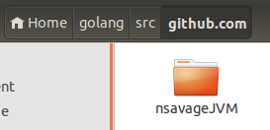

**Configure Go workspace environment** “GOPATH”

file .bashrc

set

**export GOROOT=/home/<user dir>/gotools**

**export GOPATH=/home/<user dir>/golang**

**export PATH=$PATH:$GOROOT/bin:$GOPATH/bin**

**source .bashrc**

file /etc/environment

**GOPATH=/home/<user dir>/golang**

**PATH="/usr/local/sbin:/usr/local/bin:/usr/sbin:/usr/bin:/sbin:/bin:/usr/games:/usr/local/games:/home/<user dir>/gotools/bin:/home/<user dir>/golang/bin"**

source /etc/environment

**Install Intellij ‘Go’ plugin for code completion**

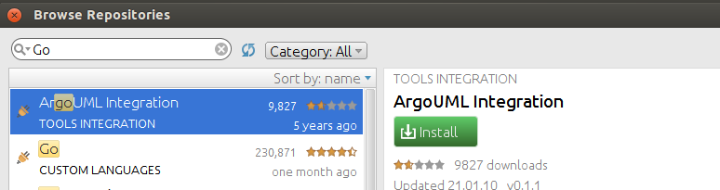

* create a directory dev1 in the $GOPATH/src/github.com/nsavageJVM directory

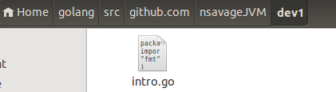

* create a file intro.go in the directory dev1 as below

**package main**

**import (**

**"fmt"**

**)**

**type info struct {**

**result string**

**}**

**func infoRepo() (string, error) {**

**return "this is the intro package", nil**

**}**

**func main() {**

**var introMssg string = "Hello from Go toolchain"**

**fmt.Println("Go reports: %+v\n ",introMssg)**

**var s = info{}**

**sp := &s**

**sp.result = "set a struct pointer value"**

**fmt.Println("Go reports: %+v\n ", sp.result )**

**}**

* run the toolchain to build the executable

**go install github.com/nsavageJVM/dev1**

If Intellij terminal does not pick up GOPATH issue in the Intellij terminal

export GOPATH=/home/<user dir>/golang

* run the executable with

**dev1**

if you see the output below you have a correctly configured go environment

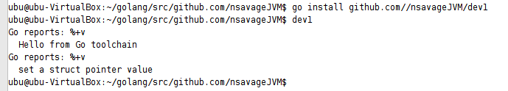

http://www.hostingadvice.com/how-to/install-golang-on-ubuntu/

sudo apt-get install curl

bash < <(curl -s -S -L https://raw.githubusercontent.com/moovweb/gvm/master/binscripts/gvm-installer)

`source /home/ubuntu/.gvm/scripts/gvm`

[[ -s "$HOME/.gvm/scripts/gvm" ]] && source "$HOME/.gvm/scripts/gvm"

source .bashrc

gvm version

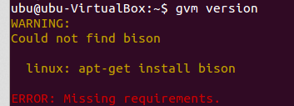

sudo apt-get install bison

gvm version



gvm install release.r60.3



<http://www.ascent.io/blog/2014/03/11/gvm-with-golang/>

<https://golang.org/doc/install>

sudo tar -C /usr/local -xzf go1.5.2.linux-amd64.tar.gz

go1.5.2.linux-amd64.tar.gz

Understanding GOROOT and GOPATH

The GOPATH environment variable is used to specify directories outside of $GOROOT that contain the source for Go projects and their binaries.

<https://www.youtube.com/watch?v=XCsL89YtqCs>

<http://blog.labix.org/2014/08/13/announcing-qml-v1-for-go>

<http://devs.cloudimmunity.com/gotchas-and-common-mistakes-in-go-golang/>

/usr/local/go/bin

<https://golang.org/doc/code.html>

mkdir -p $GOPATH/src/github.com/nsavageJVM

**go install github.com/**/nsavageJVM**/dev1**

**go install github.com/**/nsavageJVM**/rest**

https://godoc.org/github.com/jmcvetta/restclient

<https://golang.org/pkg/net/http/>

<http://www.goinggo.net/2014/03/exportedunexported-identifiers-in-go.html>

import external packages

cd $GOPATH

go get google.golang.org/cloud

go get golang.org/x/oauth2